Regional Sales Analysis
1A
Create a parameter for the Primary Region and another for the Secondary Region to allow region selection, listing all regions in them
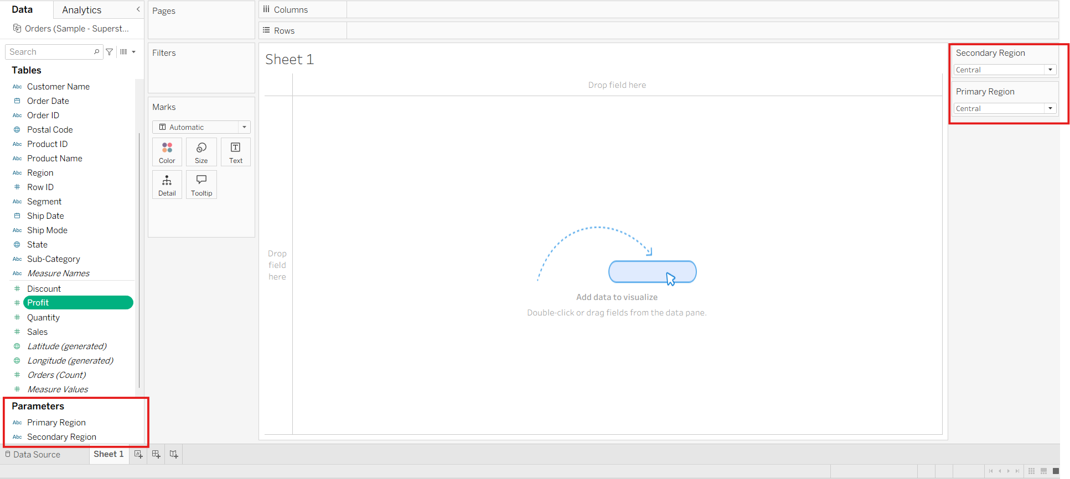

1B
Create calculated fields to filter the data based on the selected regions 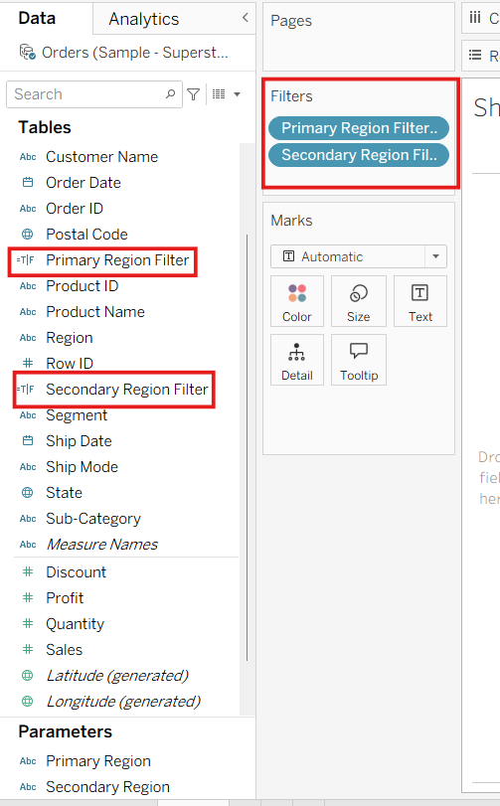
1C
Display the total sales for each region, using separate worksheets for the primary and secondary regions
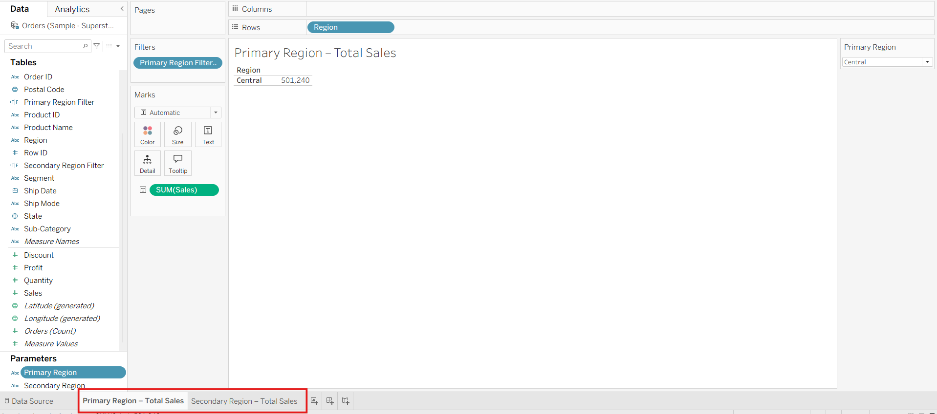
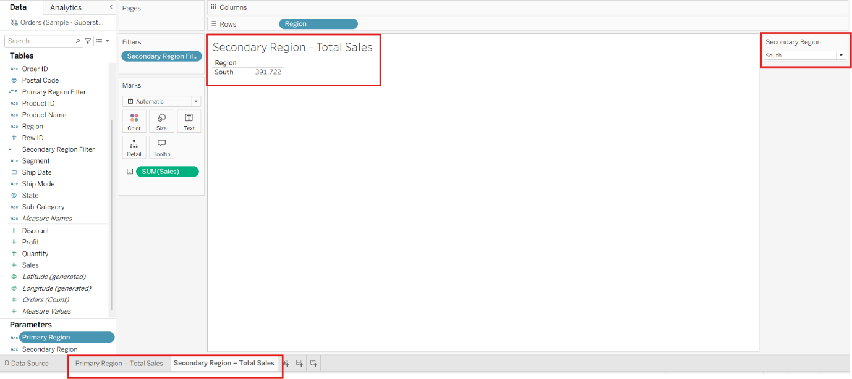

2A
Create a worksheet showing the average sales per order for both the primary and secondary regions
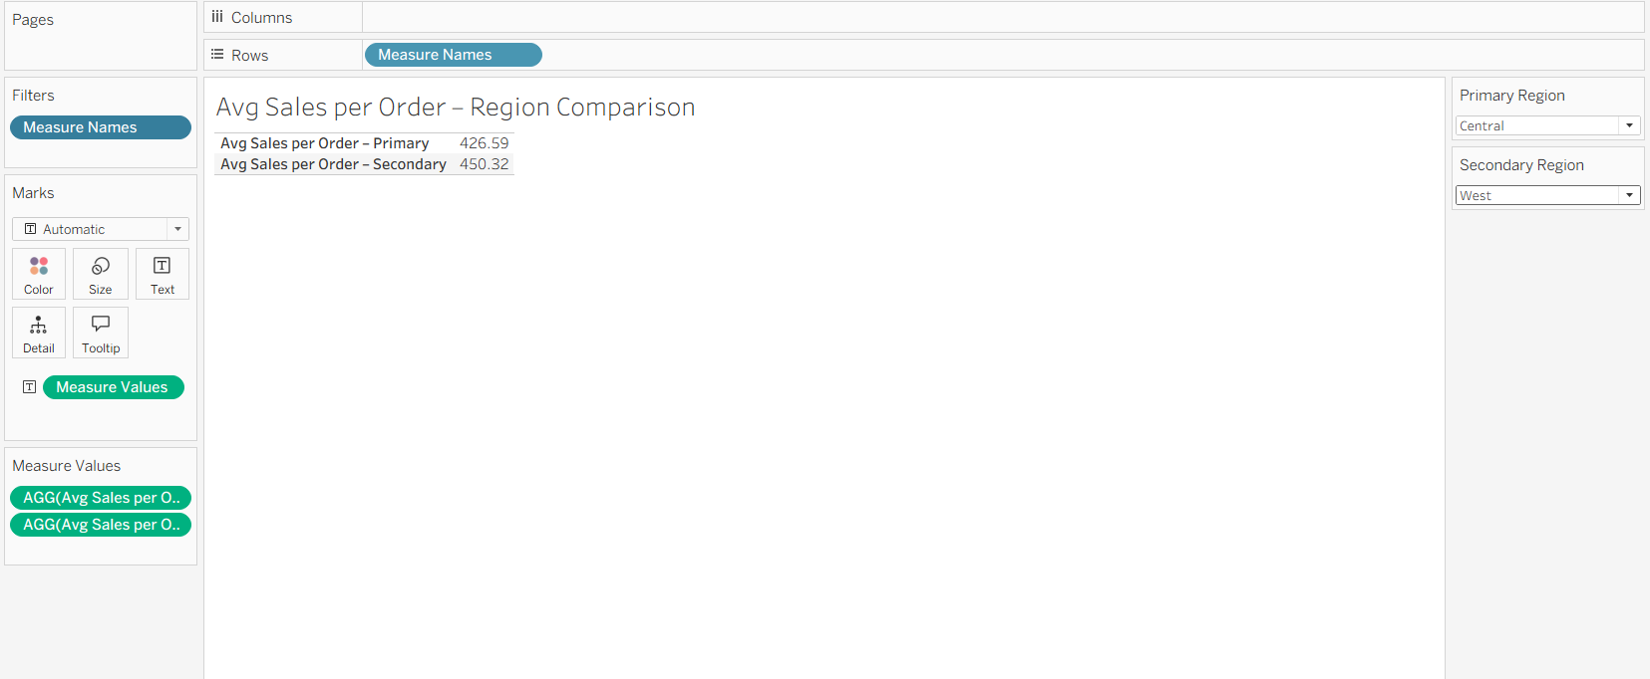
2B
Include a count of the total number of orders in each region
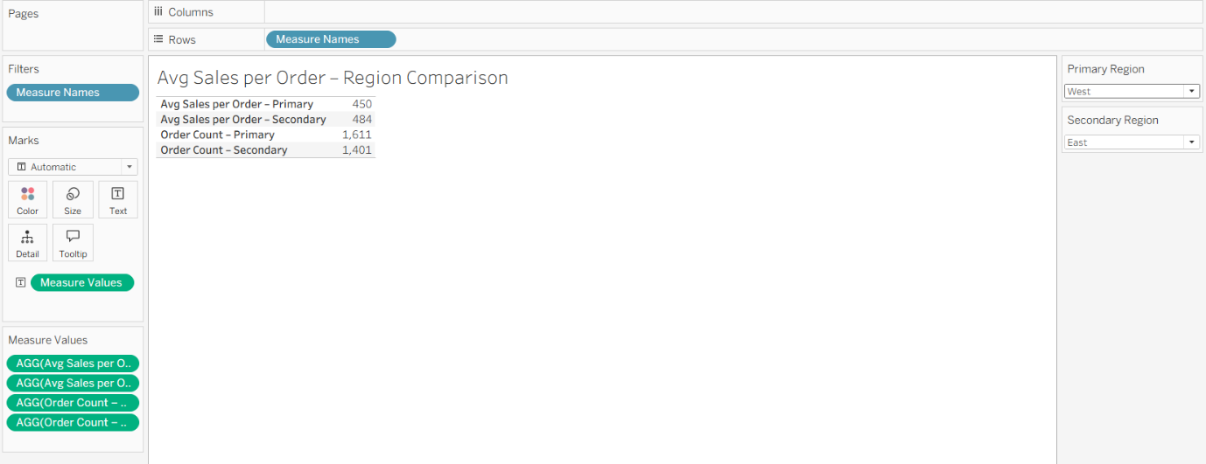
2C
Filter each worksheet to display data only for the selected region
Refer screen Source code files

3] Customer and Product Analysis:
- Create a worksheet displaying the number of unique customers in each region
- Create a worksheet showing the number of distinct products sold in each region
- Apply filters to each worksheet to ensure data accuracy for the selected regions
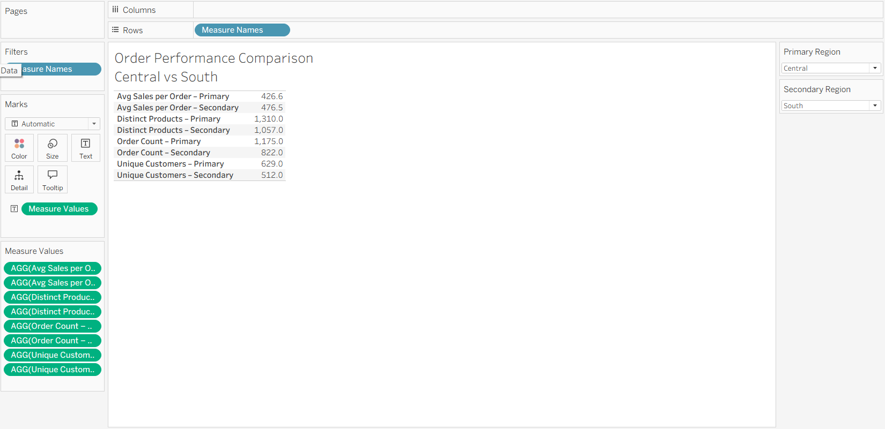

4] Comparative Analysis:
- Combine the individual worksheets into a single dashboard
- Use containers to partition the dashboard into sections for the primary and secondary regions
- Add parameter controls to allow users to select different regions and dynamically update the visualizations
